ELECTROMAGNETIC FIELD THEORY

VECTOR ANALYSIS
Vector analysis is mathematical shorthand. It has some new symbols, some new rules, and a pitfall here and there like most new fields, and it demands concentration, attention, and practice. The fundamental concepts and operations are covered in this chapter.
SCALAR
The term scalar refers to a quantity whose value may be represented by a single (positive or negative) real number.
If we speak of a body falling a distance L in a time t, or the temperature T at any point in a bowl of soup whose coordinates are x, y, and z, then L, t, T , x, y, and z are all scalars. Other scalar quantities are mass, density, pressure (but not force), volume, and volume resistivity. Voltage is also a scalar quantity, although the complex representation of a sinusoidal voltage, an artificial procedure, produces a complex scalar, or phasor, which requires two real numbers for its representation, such as amplitude and phase angle, or real part and imaginary part.

VECTOR

A vector quantity has both a magnitude and a direction in space. We shall be concerned with two- and three-dimensional spaces only, but vectors may be defined in n-dimensional space in more advanced applications.
Force, velocity, acceleration, and a straight line from the positive to the negative terminal of a storage battery are examples of vectors. Each quantity is characterized by both a magnitude and a direction.

VECTOR ALGEBRA

Vector algebra has its own set of rules, we now proceed to define the rules of vector arithmetic, vector algebra, and of vector calculus. Some of the rules will be similar to those of scalar algebra, some will differ slightly, and some will be entirely new and strange.

VECTOR ADDITION
Vector addition follows the parallelogram law, and this can be accomplished graphically as shown in Fig.1

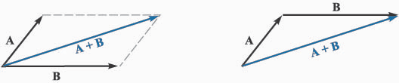

FIGURE.1

Two vectors may be added graphically either by drawing both vectors from a common origin and completing the parallelogram or by beginning the second vector from the head of the first and completing the triangle; either method is easily extended to three or more vectors.

Vector addition obeys the commutative and associative laws
i.e A + B = B + A commutative law
and A + (B + C) = (A + B)+ C associative law.
Coplanar vectors, or vectors lying in a common plane, such as those shown in Fig.1 may also be added by expressing each vector in terms of “horizontal'' and “vertical'' components and adding the corresponding components.

SUBTRACTION

The rule for the subtraction of vectors follows easily from that for addition, for we may always express A - B as A + (-B); the sign, or direction, of the second vector is reversed, and this vector is then added to the first by the rule for vector addition.
Two vectors are said to be equal if their difference is zero, or A = B if A - B =O.

MULTIPLICATION

Multiplication involving vectors will be of the following types
1. Multiplying a vector by scalar
2. Multiplying a vector by another vector

When a vector is multiplied by a scalar the magnitude of the vector changes, but its direction does not when the scalar is positive, although it reverses direction when multiplied by a negative scalar. Multiplication of a vector by a scalar also obeys the associative and distributive laws of algebra, leading to

(r + s)(A + B) = r(A + B)+ s(A + B) = rA + rB + sA + sB

The discussion on multiplying a vector by another vector is postponed for the completion of rectangular coordinate system.

DIVISION

Division of a vector by a scalar is merely multiplication by the reciprocal of that scalar.

COORDINATE SYSTEMS

In order to describe a vector accurately, some specific lengths, directions, angles, projections, or components must be given. There are three simple methods of doing this, and about eight or ten other methods which are useful in very special cases. We are going to use only the three simple methods,
1.Cartesian or rectangular coordinate system.
2.Circular cylindrical coordinate system
3.Spherical coordinate system

1. THE CARTESIAN COORDINATE SYSTEM

In the Cartesian coordinate system we set up three coordinate axes mutually at right angles to each other, and call them the x, y, and z axes. It is customary to choose a right-handed coordinate system, in which a rotation (through the smaller angle) of the x axis into the y axis would cause a right-handed screw to progress in the direction of the z axis. Fig.2a shows a right-handed Cartesian coordinate system.
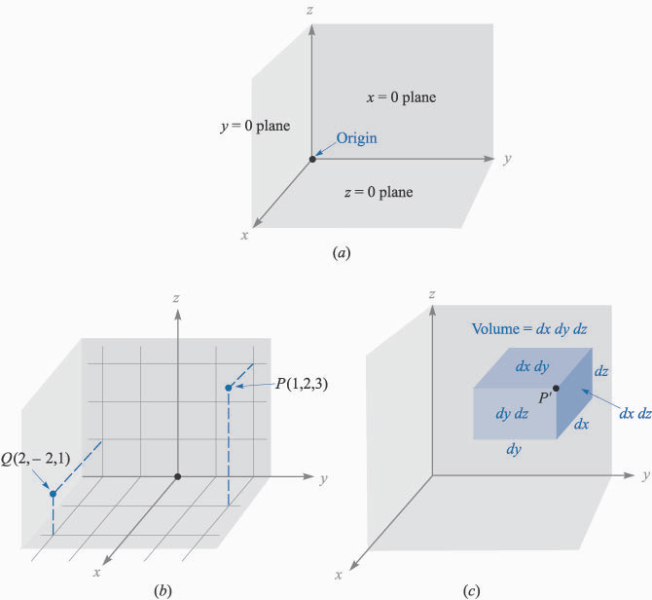
FIGURE.2a A right-handed cartesian coordinate system. If the curved fingers of the right hand indicate the direction through which the x axis is turned into coincidence with the y axis, the thumb shows the direction of the z axis.

POINT

A point in the space is defined by giving its x, y, and z coordinates. These are, respectively, the distances from the origin to the intersection of a perpendicular dropped from the point to the x, y, and z axes.
An alternative method of interpreting coordinate values , is to consider the point as being at the common intersection of three surfaces, the planes x = constant, y = constant, and z = constant, the constants being the coordinate values of the point.Fig.2b shows the points P and Q whose coordinates are (1, 2, 3) and (2, -2, 1), respectively. Point P is therefore located at the common point of intersection of the planes x = 1, y = 2, and z = 3, while point Q is located at the intersection of the planes x = 2, y = -2, z = 1.


FIGURE.2b The location of points P(l, 2, 3) and Q(2, -2, l).

In the other two coordinate systems, a point in the space is visualized as the common intersection of three surfaces, not necessarily planes, but still mutually perpendicular at the point of intersection.

VECTOR COMPONENTS AND UNIT VECTORS

To describe a vector in the cartesian coordinate system, let us first consider a vector r extending outward from the origin. A logical way to identify this vector is by giving the three component vectors, lying along the three coordinate axes, whose vector sum must be the given vector. If the component vectors of the vector r are x, y, and z, then r = x + y + z. The component vectors are shown in Fig.3a. Instead of one vector, we now have three, but this is a step forward, because the three vectors are of a very simple nature; each is always directed along one of the coordinate axes.
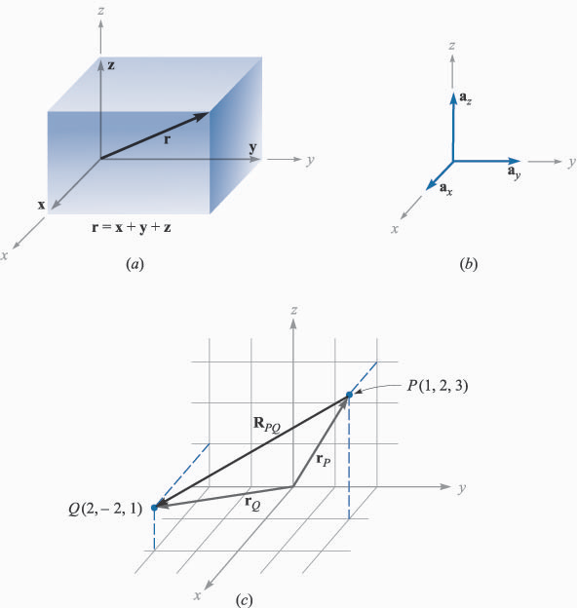

FIGURE.3a The component vectors x, y, and z of vector r.
The component vectors have magnitudes which depend on the given vector (such as r above), but they each have a known and constant direction. This suggests the use of unit vectors having unit magnitude, by definition, and directed along the coordinate axes in the direction of the increasing coordinate values. We shall reserve the symbol a for unit vector and identify the direction of the unit vector by an appropriate subscript.
Thus a_{x} , a_{y} , and a_{z} are the unit vectors in the cartesian coordinate system. They are directed along the x, y, and z axes, respectively, as shown in Fig.3b.

FIGURE.3b The unit vectors of the cartesian coordinate system have unit magnitude and are directed toward increasing values of their respective variables.

POSITION VECTOR

The vector r extending outward from the origin to the point (x, y, z) is called as the position vector which can be expressed mathematically as

r = x a_{x} + y a_{y} + z a_{z}

A vector r_{P} pointing from the origin to point P(l, 2, 3) is written r_{P} = a_{x} + 2a_{y} + 3a_{z} . The vector from P to Q may be obtained by applying the rule of vector addition. This rule shows that the vector from the origin to P plus the vector from P to Q is equal to the vector from the origin to Q. The desired vector from P(l, 2, 3) to Q(2, -2, l) is therefore

R_{PQ} = r_{Q} - r_{P} = (2 - l) a_{x} + (-2 - 2) a_{y} + (l - 3) a_{z}
= a_{x} - 4a_{y} - 2a_{z}

The vectors r_{P} , r_{Q} , and R_{PQ} are shown in Fig.3c.


FIGURE.3c The vector R_{PQ} is equal to the vector difference r_{Q} - r_{P} .

Any vector A then may be described by A = Ax a_{x} + Ay a_{y} + Az a_{z}. The magnitude of A written |A| or simply A, is given by
|A| = ( Ax ² + A_{y} ² + A_{z} ²)^{1/2}
Each of the three coordinate systems will have its three fundamental and mutually perpendicular unit vectors which are used to resolve any vector into its component vectors, also to calculate the unit vector along any vector B we write a_{B} = B/|B|

DIFFERENTIAL ELEMENTS

In rectangular coordinate system the differential elements, volume, surface and length can be expressed mathematically as follows.
If we visualize three planes intersecting at the general point P, whose coordinates are x, y, and z, we may increase each coordinate value by a differential amount and obtain three slightly displaced planes intersecting at point P¹, whose coordinates are x + dx, y + dy, and z + dz. The six planes define a rectangular parallelepiped as shown in the fig.4 .The point P¹ is indicated, but point P is located at the invisible corner.


FIGURE.4 The differential volume element in Cartesian coordinates; dx, dy and dz are in general, independent differentials.

Now the differential volume dv = dxdydz (scalar)
the differential length, dL = dx a_{x} + dy a_{y} + dz a_{z} ( vector)
and the six differential surfaces are ±dxdy a_{z} , ±dxdz a_{y}, ±dydz a_{x} (vectors)
THE FIELD
A field (scalar or vector) may be defined mathematically as some function of that vector which connects an arbitrary origin to a general point in space or simply a field is the function of a position vector. If r is the position vector then a field F can be expressed in functional notation as F(r).

Scalar Field

A scalar field is a function that gives us a single value of some variable for every point in space (or) A scalar field is a field for which there is a single number associated with every point in space.
As an example, let the scalar field F be defined as
F(r) = F(x,y,z) = xy – x²yz + yz
This expression defines the value of the scalar function F at every point (x,y,z) in space.
VECTOR Field
A vector field is a quantity which has both a magnitude and a direction at every point in space. Vectors fields are used to describe physical quantities such as velocity, momentum, acceleration and force, associated with an object.
As an example, let the vector field F be defined as
F(r) = F(x,y,z) = xy a_{x} – x²yz a_{y} + yz a_{z}
This expression defines the value of the vector function F at every point (x,y,z) in space.

PRODUCT OF TWO VECTORS
Let us now consider multiplication of a vector by another vector which is of two types, one is the dot product and the other cross product.

THE DOT PRODUCT
Given two vectors A and B, the dot product, or scalar product, is defined as the product of the magnitude of A, the magnitude of B, and the cosine of the smaller angle between them,
A·B = |A| |B| cos θ_{AB}
The dot, or scalar, product is a scalar, as one of the names implies, and it obeys the commutative law,
A·B = B·A
APPLICATIONS
1. The most common application of the dot product is in mechanics, where a constant force F applied over a straight displacement L does an amount of work FL cos θ, which can be more easily written as F·L
If the force F varies along the path, then the total work done W = ∫ F·dL

2. The total flux crossing a surface of area S is given by BS if the magnetic flux density B is perpendicular to the surface and uniform over it.
If we define a vector surface S as having the usual area for its magnitude and having a direction normal to the surface and the magnetic flux density B is uniform over S, then flux crossing the surface is B ·S.
If the flux density is not constant over the surface, then the total flux, ϕ = ∫ B·dS

3. The angle between two vectors in three-dimensional space can be calculated as follows
If A = Ax a_{x} + Ay a_{y} + Az a_{z} and B = B_{x} a_{x} + B_{y} a_{y} + B_{z} a_{z} then cosθ = A·B ̸ |A| |B|

4. One of the most important applications of the dot product is that of finding the component of a vector in a given direction.
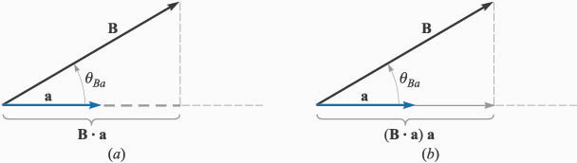
FIGURE 5
Fig5(a) shows the scalar component of B in the direction of the unit vector a which is B·a. and (b) shows the vector component of B in the direction of the unit vector a as (B·a)a. The scalar component B·a is also called as projection of B along the direction a.
THE CROSS PRODUCT
Given two vectors A and B, the cross product or vector product of A and B is written as A x B.The cross product A x B is a vector; the magnitude of A x B is equal to the product of the magnitudes of A, B and the sine of the smaller angle between A and B; the direction of A x B is perpendicular to the plane containing A and B and is along that one of the two possible perpendiculars which is in the direction of advance of a right-handed screw as A is turned into B. This direction is illustrated in Fig.6
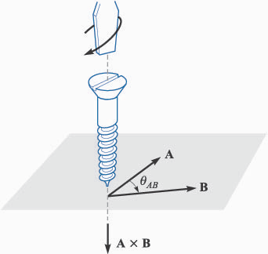
A x B = a_{N} |A| |B| sin θ_{AB}

The direction of A x B is in the direction of advance of a right-handed screw as A is turned into B.
The cross product is not commutative, for B x A = -(A x B).
If the definition of the cross product is applied to the unit vectors, a_{x} x a_{y} = a_{z} ; a_{y} x a_{z} = a_{x} and a_{z} x a_{x} = a_{y} .
FIGURE 6
APPLICATIONS
1. To find the area of a parallelogram, the product of the lengths of two adjacent sides is multiplied by the sine of the angle between them. Using vector notation for the two sides, we then may express the (scalar) area as the magnitude of A x B, or |A x B|.
2.Consider the force on a straight conductor of length L, where the direction assigned to L corresponds to the direction of the steady current I , and a uniform magnetic field of flux density B is present. Using vector notation, we may write the result neatly as F = I L x B.
CALCULATION OF AxB
The evaluation of a cross product by means of its definition turns out to be more work than the evaluation of the dot product from its definition, for not only must we find the angle between the vectors, but we must find an expression for the unit vector a_{N} . This work may be avoided by using cartesian components for the two vectors A and B and expanding the cross product as a sum of nine simpler cross products,
A x B = A_{x} B_{x} a_{x} x a_{x} + A_{x} By a_{x} x a_{y} + A_{x} B_{z} a_{x}x a_{z}
+ A_{y} B_{x} a_{y}x a_{x} + A_{y} B_{y} a_{y}x a_{y} + A_{y} B_{z} a_{y}x a_{z}
+ A_{z} B_{x} a_{z} x a_{x} + A_{z} B_{y} a_{z} x a_{y} + A_{z} B_{z} a_{z} x a_{z}

since a_{x} x a_{y} = a_{z} ; a_{y} x a_{z} = a_{x} and a_{z} x a_{x} = a_{y} and the cross product of any vector with itself is zero,

A x B = (A_{y} B_{z} –A_{z} B_{y} )a_{x} + (A_{z} B_{x} –A_{x} B_{z} )a_{y} +(A_{x} B_{y} –A_{y} B_{x} )a_{z}

2. CIRCULAR CYLINDRICAL COORDINATE SYSTEM

The Cartesian coordinate system is generally the one in which students prefer to work every problem. This often means a lot more work for the student, because many problems possess a type of symmetry which pleads for a more logical treatment. It is easier to do now, the work required to become familiar with cylindrical and spherical coordinates, instead of applying an equal or greater effort to every problem involving cylindrical or spherical symmetry later. With this future saving of labour in mind, we shall take a careful and unhurried look at cylindrical and spherical coordinates.

The circular cylindrical coordinate system is the three-dimensional version of the polar coordinates of analytic geometry. In the two-dimensional polar coordinates, a point was located in a plane by giving its distance ρ from the origin, and the angle ϕ between the line from the point to the origin and an arbitrary radial line, taken as ϕ= 0. A three-dimensional coordinate system, circular cylindrical coordinates, is obtained by also specifying the distance z of the point from an arbitrary z = 0 reference plane which is perpendicular to the line ρ = 0. For simplicity, we usually refer to circular cylindrical coordinates simply as cylindrical coordinates, but it is fair to point out that there are such systems as elliptic cylindrical coordinates, hyperbolic cylindrical coordinates, parabolic cylindrical coordinates, and others.
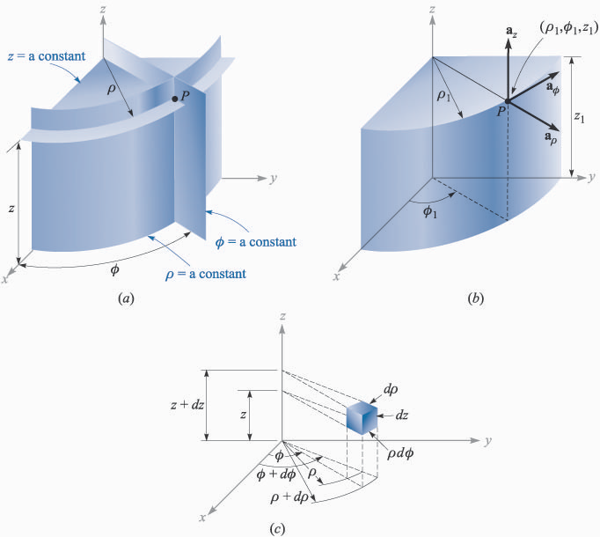

FIGURE 7(a)The three mutually perpendicular surfaces of the circular cylindrical coordinate system.

POINT

We no longer set up three axes as in cartesian coordinates, but must instead consider any point as the intersection of three mutually perpendicular surfaces. These surfaces are a circular cylinder (ρ = constant), a plane (ϕ = constant), and another plane (z = constant) as shown in fig.7(a).Note that three such surfaces may be passed through any point, unless it lies on the z axis, in which case one plane suffices.

UNIT VECTORS

Three unit vectors must also be defined, but we may no longer direct them along the "coordinate axes,'' for such axes exist only in cartesian coordinates. Instead, we take a broader view of the unit vectors in cartesian coordinates and realize that they are directed toward increasing coordinate values and are perpendicular to the surface on which that coordinate value is constant (i.e., the unit vector a_{x} is normal to the plane x = constant and points toward larger values of x). In a corresponding way we may now define three unit vectors in cylindrical coordinates, a_{ρ} , a_{ϕ} , and a_{z} .


FIGURE 7(b)The three unit vectors of the circular cylindrical coordinate system.

The unit vector a_{ρ} at a point P(ρ₁ , ϕ₁ , z₁ ) is directed radially outward, normal to the cylindrical surface ρ= ρ₁ . It lies in the planes ϕ = ϕ₁ and z = z₁ .

The unit vector a_{ϕ} is normal to the plane ϕ= ϕ₁ , points in the direction of increasing ϕ, lies in the plane z = z₁ , and is tangent to the cylindrical surface ρ= ρ₁.
The unit vector a_{z} is the same as the unit vector a_{z} of the cartesian coordinate system. Fig.7(b) shows the three vectors in cylindrical coordinates.
In cartesian coordinates, the unit vectors are not functions of the coordinates. Two of the unit vectors in cylindrical coordinates, a_{ρ} and a_{ϕ}, do vary with the coordinate ϕ, since their directions change. Hence, in integration or differentiation with respect to ϕ, a_{ρ} and a_{ϕ} must not be treated as constants.
The unit vectors are again mutually perpendicular, for each is normal to one of the three mutually perpendicular surfaces, and we define a right- handed cylindrical coordinate system as one in which a_{ρ} x a_{ϕ} = a_{z} ,a_{ϕ} x a_{z} = a_{ρ} and a_{z} x a_{ρ} = a_{ϕ} .
Any vector A then may be described by A = A_{ρ} a_{ρ} + A_{ϕ} a_{ϕ} + A_{z} a_{z} i.e. by identifying the components of A along the unit vectors the vector A can be described completely.
POSITION VECTOR
The vector r extending from origin to any point (ρ,ϕ,z) is called as position vector. The components of r along the unit vectors a_{ρ} , a_{ϕ}, a_{z} are ρ,0,z respectively. Hence
r = ρ a_{ρ} + z a_{z} is the position vector of the point (ρ,ϕ,z). DIFFERENTIAL ELEMENTS


A differential volume element in cylindrical coordinates may be obtained by increasing ρ, ϕ,and z by the differential increments dρ, dϕ, and dz. The two cylinders of radius ρ and ρ + dρ, the two radial planes at angles ϕ and ϕ+ dϕ and the two "horizontal'' planes at "elevations'' z and z + dz now enclose a small volume, as shown in Fig.7(c), having the shape of a truncated wedge. As the volume element becomes very small, its shape approaches that of a rectangular parallelepiped having sides of length dρ, ρdϕ and dz. Note that dρ and dz are dimensionally lengths, but dϕ is not; ρdϕ is the length.

Now the differential volume dv = ρ dρ dϕ dz
the differential length, dL = dρ a_{ρ} + ρdϕ a_{ϕ}+ ρdϕ a_{z}
and the six differential surfaces are ± ρ dρ dϕ a_{z}, ± ρdϕ dz a_{ρ}, and ± dρ dz a_{ϕ}

RELATING RECTANGULAR AND CYLINDRICAL COORDINATES
The variables of the rectangular and cylindrical coordinate systems can be related easily to each other as shown in the figure given below.
FIGURE 8.The relationship between the cartesian variables x, y, z and the cylindrical coordinate variables ρ , ϕ, z. There is no change in the variable z between the two systems

From the fig.8 we have
x = ρ cosϕ
y = ρ sinϕ
z = z
From the other viewpoint, we may express the cylindrical variables in terms of x, y, and z as
ρ = (x² + y ² )^{1/2}
ϕ = tan⁻¹(y/x)
z = z
Here we shall consider the variable ρ to be positive or zero and the proper value of the angle ϕ is determined by inspecting the signs of x and y. For example, if x = -3 and y = 4, we find that the point lies in the second quadrant so that ρ = 5 and ϕ = 126.9°. For x = 3 and y = -4, we have ϕ = -53.1° or 306.9°, whichever is more convenient.
From the above set of equations, scalar functions given in one coordinate system can be easily transformed into the other system.
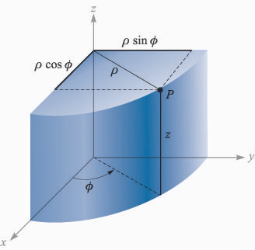
VECTOR TRANSFORMATION : RECTANGULAR <=> CYLINDRICAL
A vector function in one coordinate system, requires two steps in order to transform it to another coordinate system
RECTANGULAR TO CYLINDRICAL
Let A be the vector in rectangular coordinates
A = A_{x} a_{x} + A_{y} a_{y} + A_{z} a_{z} , here each component ( A_{x}, A_{y}, or A_{z}) is a function of x, y, and z. After transformation the vector A should be in cylindrical coordinates and A = A_{ρ} a_{ρ} + A_{ϕ} a_{ϕ} + A_{z} a_{z} , where each component is a function of ρ, ϕ and z. This transformation requires two steps as said earlier.
Step1:Calculation of cylindrical components A_{ρ} , A_{ϕ} and A_{z} (transformation of the components)
Since A_{ρ}, A_{ϕ} and A_{z} are the components of given vector A (A = A_{x} a_{x} + A_{y} a_{y} + A_{z} a_{z} ) along a_{ρ}, a_{ϕ} and a_{z} directions, A_{ρ}= A·a_{ρ} and A_{ϕ} = A·a_{ϕ} ( as z coordinate is same in both the coordinate systems A_{z} is also same and need not be calculated separately)
hence
A_{ρ}= A·a_{ρ} = (A_{x} a_{x} + A_{y} a_{y} + A_{z} a_{z}) ·a_{ρ} = A_{x} a_{x}·a_{ρ} + A_{y} a_{y}·a_{ρ} (as a_{z}·a_{ρ} =0)
A_{ϕ} = A·a_{ϕ} = (A_{x} a_{x} + A_{y} a_{y} + A_{z} a_{z}) ·a_{ϕ} = A_{x} a_{x}·a_{ϕ} + A_{y} a_{y}·a_{ϕ} (as a_{z}·a_{ϕ} =0)
also A_{z}= A·a_{z} = (A_{x} a_{x} + A_{y} a_{y} + A_{z} a_{z}) ·a_{z} = A_{z} a_{z}·a_{z} = A_{z}
Now it is necessary to know the dot products a_{x}·a_{ρ}, a_{y}·a_{ρ}, a_{x}·a_{ϕ}, and a_{y}·a_{ϕ}. Applying the definition of the dot product, from the fig.7(b) we have the values of the dot products as shown in the table.
 | a_{ρ} | a_{ϕ} | a_{z}
a_{x} · | cosϕ | -sinϕ | 0
a_{y} · | sinϕ | cosϕ | 0
a_{z} · | 0 | 0 | 1
TABLE.1Dot products of unit vectors in cylindrical and cartesian coordinate systems
The values of the dot products can be used in the above expressions to calculate A_{ρ}, A_{ϕ} and A_{z}
Step 2:In order to complete the transformation, A_{x}, A_{y} and A_{z} that appear in A_{ρ}, A_{ϕ} and A_{z} are now to be expressed in terms of ρ, ϕ and z (because A_{x}, A_{y} and A_{z} are functions of x, y and z) using
x = ρ cosϕ
y = ρ sinϕ
z = z.

CYLINDRICAL TO RECTANGULAR
In order to transform a vector from cylindrical to rectangular coordinates, the procedure is identical to the one illustrated above.
3. THE SPHERICAL COORDINATE SYSTEM

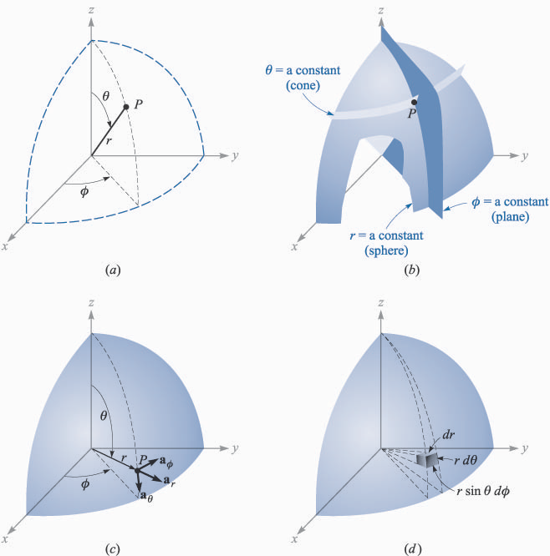
Let us start by building a spherical coordinate system on the three cartesian axes . We first define the distance from the origin to any point as r. The second coordinate is an angle θ between the z axis and the line drawn from the origin to the point.
The third coordinate ϕ is also an angle and is exactly the same as the angle ϕ of cylindrical coordinates. It is the angle between the x axis and the projection in the z = 0 plane of the line drawn from the origin to the point.

FIGURE 9(a).The three spherical coordinates.

POINT
Here, we consider any point in the space as as the intersection of three mutually perpendicular surfaces as shown in fig.9(b).

The three surfaces are
r = constant, a sphere
θ = constant, a cone and
ϕ = constant, a plane

The two surfaces, cone and sphere, are everywhere perpendicular along their intersection, which is a circle of radius r sinθ.

FIGURE 9(b).The three mutually perpendicular surfaces of the spherical coordinate system.

UNIT VECTORS

Three unit vectors namely a_{r}, a_{θ} and a_{ϕ} can be defined at any point in space. Each unit vector is perpendicular to one of the three mutually perpendicular surfaces and oriented in that direction in which the coordinate increases.


FIGURE 9(c).The three unit vectors of spherical coordinates

The unit vector a_{r} is directed radially outward, normal to the sphere r = constant, and lies in the cone θ = constant and the plane ϕ = constant.
The unit vector a_{θ} is normal to the conical surface, lies in the plane, and is tangent to the sphere.
The third unit vector a_{ϕ} is the same as in cylindrical coordinates, being normal to the plane and tangent to both the cone and sphere. The three unit vectors are mutually perpendicular.
Usually right- handed coordinate systems are used. We define the right-handed spherical coordinate systems as the one, in which a_{r} x a_{θ} = a_{ϕ} ;a_{θ} x a_{ϕ} = a_{r} and a_{ϕ} x a_{r} = a_{θ}.
(Note: The system is said to be right handed if the rotation from a_{r} to a_{θ} through the smaller angle causes a right handed screw to progress in the direction of a_{ϕ} i.e. if a_{r} x a_{θ} = a_{ϕ} )
Any vector A then may be described by A = A_{r} a_{r} + A_{θ} a_{θ} + A_{ϕ} a_{ϕ} i.e. by identifying the components of A along the unit vectors the vector A can be described completely.
POSITION VECTOR
The vector r extending from origin to any point (r, θ, ϕ) is called as position vector. The components of r along the unit vectors a_{r}, a_{θ} and a_{ϕ} are r, 0 and 0 respectively. Hence
r = r a_{r} is the position vector of the point (r, θ, ϕ)

DIFFERENTIAL ELEMENTS
Differential volume element may be constructed in spherical coordinates by increasing r, θ and ϕ by dr, dθ and dϕ , as shown in Fig.

The distance between the two spherical surfaces of radius r and r + dr is dr; the distance between the two cones having generating angles of θ and θ + dθ is r dθ ; and the distance between the two radial planes at angles ϕ and ϕ + dϕ is found to be r sinθ dϕ

FIGURE 9(d).The differential volume element in the spherical coordinate system.

Now the differential volume dv = r² sinθ dr dθ dϕ
the differential length, dL = dr a_{r} + r dθ a_{θ} + r sinθ dϕ a_{ϕ}
and the six differential surfaces are ± r dr dθ a_{ϕ} , ± r² sinθ dθ dϕ a_{r} and ± r sinθ dr dϕ a_{θ}
RELATING RECTANGULAR AND SPHERICAL COORDINATES
The variables of the rectangular and spherical coordinate systems can be related easily to each other by inspecting the figure given below.
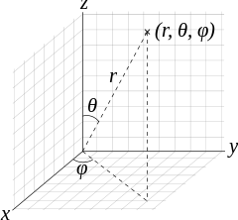
x = r sinθ cosϕ
y = r sinθ sinϕ
z = r cosθ

and the transformation in the reverse direction is achieved with the help of the following
r = (x² + y² + z²)^{1/2} (r ≥ 0)
θ = cos⁻¹ ($\frac{z}{√x2 + y2 + z2}$) (0⁰ ≤ θ ≤180⁰)
FIGURE 10 ϕ = tan⁻¹$\frac{y}{x}$

The angles are placed in the proper quadrants by inspecting the signs of x, y, and z.
VECTOR TRANSFORMATION: RECTANGULAR <=> SPHERICAL
In order to transform a vector, either from rectangular to spherical or from spherical to rectangular, it requires two steps.
RECTANGULAR TO SPHERICAL
Let A be the vector in rectangular coordinates
A = A_{x} a_{x} + A_{y} a_{y} + A_{z} a_{z} , here each component ( A_{x}, A_{y}, A_{z} ) is a function of x, y, and z. After transformation the vector A should be in spherical coordinates and A = A_{r} a_{r} + A_{θ} a_{θ} + A_{ϕ} a_{ϕ} , where each component is a function of r, θ, and ϕ. This transformation requires two steps as said earlier.
Step1:Calculation of spherical components A_{r} , A_{θ} and A_{ϕ} (transformation of the components)
Since A_{r} , A_{θ} and A_{ϕ} are the components of given vector A (A = A_{x} a_{x} + A_{y} a_{y} + A_{z} a_{z}) along a_{r}, a_{θ} and a_{ϕ} directions, A_{r} = A·a_{r} ; A_{θ} = A·a_{θ} and A_{ϕ} = A·a_{ϕ}
hence
A_{r} = A·a_{r} = (A_{x} a_{x} + A_{y} a_{y} + A_{z} a_{z} ) ·a_{r} = A_{x} a_{x}·a_{r} + A_{y} a_{y}·a_{r} + A_{z} a_{z}·a_{r}
A_{θ} = A·a_{θ} = (A_{x} a_{x} + A_{y} a_{y} + A_{z} a_{z} ) ·a_{θ} = A_{x} a_{x}·a_{θ} + A_{y} a_{y}·a_{θ} + A_{z} a_{z}·a_{θ}
also A_{ϕ} = A·a_{ϕ} = (A_{x} a_{x} + A_{y} a_{y} + A_{z} a_{z} ) ·a_{ϕ} = A_{x} a_{x}·a_{ϕ} + A_{y} a_{y}·a_{ϕ} + A_{z} a_{z}·a_{ϕ}
Now it is necessary to know the dot products of the unit vectors specified above. Since the dot product of any spherical unit vector with any cartesian unit vector is the component of the spherical vector in the direction of the cartesian vector, the dot products with a_{z} are found to be

a_{z}·a_{r} = cosθ
a_{z}·a_{θ} = -sinθ
a_{z}·a_{ϕ} = 0
The dot products involving a_{x} and a_{y} require first the projection of the spherical unit vector on the xy plane and then the projection onto the desired axis.
For example, a_{r}· a_{x} is obtained by projecting a_{r} onto the xy plane, giving sinθ, and then projecting sinθ on the x axis, which yields sinθ cosϕ. The other dot products are found in a similar FIGURE 11.
manner, and all are shown in Table 2.
 | a_{r} | a_{θ} | a_{ϕ}
a_{x} · | sinθ cosϕ | cosθ cosϕ | -sinϕ
a_{y} · | sinθ sinϕ | cosθ sinϕ | cosϕ
a_{z} · | cosθ | -sinθ | 0
TABLE.2Dot products of unit vectors in spherical and cartesian coordinate systems

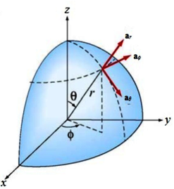
Hence the values of the dot products can be used in the above expressions to calculate A_{r} , A_{θ}, and A_{ϕ} .
Step 2:In order to complete the transformation, A_{x} , A_{y} and A_{z} that appear in A_{r} , A_{θ}, and A_{ϕ} are now to be expressed in terms of r, θ, and ϕ (because A_{x} , A_{y} and A_{z} are functions of x, y, and z) using
x = r sinθ cosϕ
y = r sinθ sinϕ
z = r cosθ
SPHERICAL TO RECTANGULAR
In order to transform a vector from spherical to rectangular coordinates, the procedure is identical to the one illustrated above.

